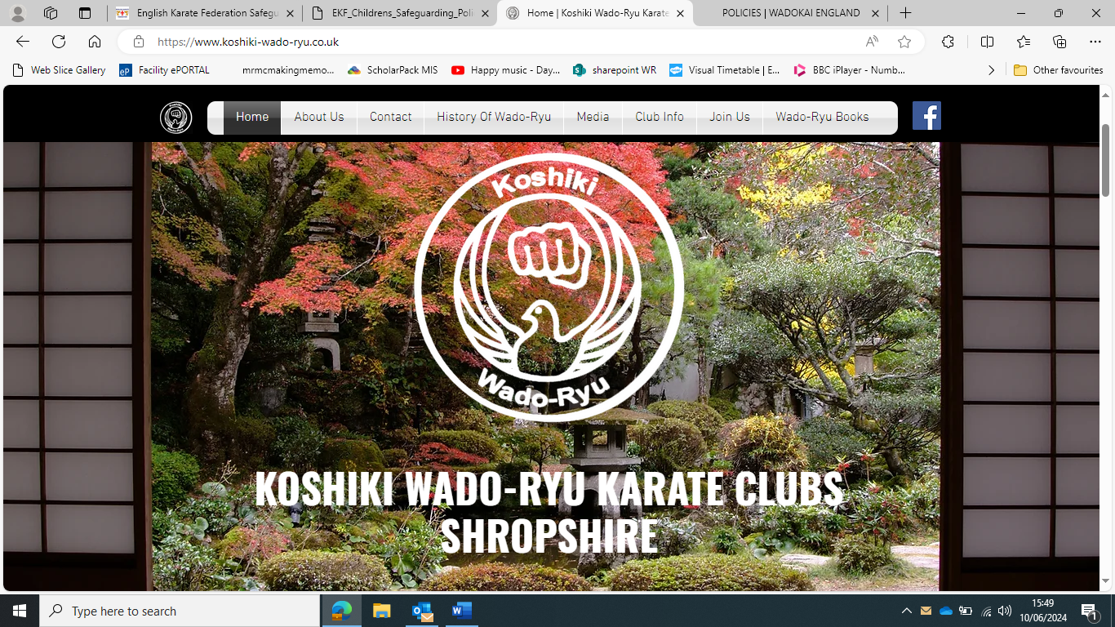
Safeguarding Policy for Children and Adults
June 2024
Review: June 2028
Introduction
Throughout this document there will be references to Wado-Ryu karate do and Koshiki club. Whenever ‘the child’ or ‘children’ is mentioned, this includes children under the age of 18 and vulnerable people or groups of people of any age.
Koshiki club fully recognises the need to make optimal provision for the safeguarding and wellbeing of children and young persons, that participate in the sport of karate, either as a self-defence art or sport environment, and acknowledges its moral and legal responsibility to ensure that:
- The welfare of its participants is paramount
- All children, whatever the age, culture, disability, gender, language, race, religion, and / or sexuality have the right to be protected from abuse
- All suspicions of abuse and allegations of abuse will be taken seriously and will be responded to swiftly and appropriately
- All staff (paid or unpaid) or officials working within our sport have a duty to report concerns to Koshiki clubs senior designated safeguarding lead (Sensei Frank Johnson) who will seek advice and/or escalate concerns to family connect Telford 01952 385385.
Adopting best practice will help to safeguard children from potential abuse as well as protecting coaches and other adults in positions of responsibility from any potential allegation of abuse.
Policy Statement
Koshiki Club recognises its duty of care to safeguard all children and vulnerable persons involved in all forms of karate from harm. All children and vulnerable persons have a right to protection; while the needs of disabled children and other vulnerable groups must be taken into account. Koshiki club will strive to ensure the safety and protection of all children and vulnerable persons involved in our sport through adherence to safeguarding guidelines.
Sport can and does have a powerful and positive influence on children. Not only can it provide opportunities for achievement; it helps to develop and enhance valuable qualities such a self- esteem, confidence, teamwork and leadership. To ensure the promotion of positive experiences Koshiki club must ensure that those adults who have a direct influence on the children and vulnerable groups are that of a high moral standing. These adults must have good knowledge of how to teach the sport whilst having a positive influence on the children’s self-esteem.
Policy Aims
The aim of the Safeguarding Policy is to promote good practice:
- If contact is made during training the children will be provided with appropriate protective attire (mitts or gloves for light sparring). When the pupil has an increased knowledge of Wado Karate and is fully licensed they may entertain full contact fighting in which they will be asked to provide their own mouth guards, helmet, gloves, shin pads and foot protectors.
- Ensure that all incidents of poor practice and allegations of abuse will be taken seriously and reported swiftly and appropriately to the senior safeguarding lead using the appropriate safeguarding concern form (APPENDIX 1).
- Koshiki club recognises that vulnerable groups of people of any age also need to be taken into consideration in the Safeguarding Policy and that they will be treated fairly and inclusively
- Koshiki club has its own Senior designated safeguarding lead. The DSSL will ensure that all staff and volunteers in an influential position within Koshiki will have basic safeguarding knowledge, and will be briefed on how to report an incident, keeping confidentiality and dignity mindful at all times.
Good Practice Guidelines
All those involved in WKE will be encouraged to demonstrate exemplary behaviour in order to safeguard children and to protect themselves from false allegations. The following guidelines will help to promote good practice, in turn protecting children from the possibility of abuse, and protecting adults from false allegations of abuse:
- Always work in an open environment (e.g. avoid being alone with a child)
- Treat all young people, vulnerable and disabled adults equally, and treat them with respect and dignity
- Always place the welfare and safety of children first above the development or performance of competition
- Maintain a safe and appropriate distance whilst partnering and working with children. Avoid any un necessary contact. Fighting distances and partner work distances can vary but must be maintained and minimal necessary contact can be made in this instance to perform the technique adequately.
- The Sensei of the club will keep up to date with technical skills, qualifications and their own insurance. They will also ensure and keep record of insurances of their pupils to ensure that they are fully covered at all times. A license can be acquired within the first 6 weeks of training.
- Involve parents and carers where possible (e.g. for the responsibility of their own child in the changing rooms)
- Currently Koshiki club does not enter tournaments but if they do in the future; Ensure that at tournaments or residential events, adults must not enter children’s rooms, nor should they allow children into their rooms unless accompanied by a responsible person
- Give constructive and enthusiastic feedback to the children rather than negative criticism
- Recognise the developmental needs and capabilities of the children and vulnerable adults (e.g. avoid excessive training or competition and do not push them against their will)
- Secure parental consent to provide emergency first aid if required with the parent absent (APPENIDIX 2.1)
- Keep written record of any accident/incident/injury along with details of any treatment given/action taken (APPENDIX 2.2)
Recording and reporting of incidents (APPENDIX 3)
It may a times be necessary for adults to do things of a personal nature for children, vulnerable adults and disabled people. These tasks must only be carried out with the full understanding and consent of the parent and pupil. If a person is fully dependant on you, talk to him or her about what you are doing and give choices where possible.
If any of the following occur you should report this immediately to the Child Protection Officer and the incident must be recorded. The parents must also be informed if:
- You accidently hurt a child
- He or she seems distressed in any manner
- A student appears sexually aroused by your actions
- A child misunderstands or misinterprets something you have done, and this leads them to understand you have acted in an inappropriate manner

Use of photographic/filming equipment and social media usage
ANY concerns regarding photography or videography must be reported directly to the Senior designated safeguarding lead.
Koshiki club reserves the right to ask people to stop photographing or videoing at any time (to include, but not exclusively, Wado Ryu training events and competitions), although we will try to provide a reason for the request, in the interests of confidentiality this may not always be possible. Failure to adhere to this may result in dismissal from Koshiki Club. Koshki club will ask for anyone joining the club to sign a photographic release. Koshiki club will ensure that this form is adhered to. Koshiki may use club pictures for social media pages with parental consent (APPENDIX 4).
Senseis and club coaches
All Senseis and assistant coaches are required to provide a copy of their CRB/DBS. If the coach should be charged with any criminal offence after this has been provided, this must be disclosed to the Child Protection Officer, failure to do so may result in instant dismissal. All disclosures will be kept in strict confidence.
Defining Child Abuse
There are four main types of abuse:
- Physical abuse: This includes, but not exclusively, being hit, kicked, shaken, pushed or punched, or being given harmful drugs or alcohol
- Emotional abuse: This includes, but not exclusively, being called names, being threatened, being shouted at or being belittled
- Sexual abuse: This includes, but not exclusively, being touched in a way you don’t like by an adult or young person, being forced to have sex, being involved in sexually inappropriate conversations, being made to look at sexually inappropriate material
- Neglect: Is when a child is not being looked after properly which includes, but is not exclusive to, not having enough to eat or drink, not having a proper place to stay, not enough clothes to keep them warm. It also includes if a child needs medical care and it is not provided
Another form of abuse to be recognised alongside the four main areas of abuse is:
- Bullying: This includes, but is not exclusive to, hitting or threatening with violence, taking their belongings, calling names, insulting or mocking them, making them do things they do not want to do, deliberately humiliating or ignoring them.
Common signs of abuse
Every child is unique, so behavioural signs of abuse will vary from child to child. In addition, the impact of the abuse is likely to be influenced by the child’s age, the nature and extent of the abuse, and the help and support that the child receives. However, there are some behaviours that are commonly seen in children and young children who have been/are being abused:
- The child appears distressful of a particular adult, or a parent or coach whom you would expect the child to be close to
- He or she has unexplained injuries such as bruises, bites or burns-particularly if they are in a place where you would not expect to see them
- He or she has an injury which cannot be explained satisfactorily or has not been properly treated
- Deterioration in his or her physical appearance or a rapid weight gain/loss
- Pains, itching, bruising or bleeding in or near the genital area
- A change in the child’s general behaviour (e.g. they may become unusually quiet and withdrawn, or unexpectedly aggressive-these changes can be sudden or gradual)
- If he or she refuses to remove clothing for normal activities or wants to keep covered up all the time even in warm weather
- He or she shows inappropriate sexual awareness or behaviour for their age
These signs should be seen as a possible indication of abuse, not as evidence of abuse. Changes in a child’s behaviour can result from a wide range of factors; equally physical signs of abuse can also have an innocent explanation. It is difficult to determine whether or not something is worth reporting, but if in any doubt, report it.
N.B. All areas of suspected child abuse should be reported to the Senior designated safeguarding lead even if there is no evidence that the abuse is being inflicted by anyone directly linked with Koshiki club.
Responding to suspicions or allegations
It is not the responsibility of anyone working for Koshiki club (in a paid or unpaid capacity) to decide whether or not child abuse has taken place. This is the role of the Child Protection Agencies, however there is a responsibility for all involved in Koshiki club to act on any concerns through contact with the appropriate authorities.
Advice and information is available through Family Connect 01952385385 , The Police 111/999, or the NSPCC 24 hour helpline.
Koshiki club assures all staff and volunteers that it will fully support anyone who in good faith, reports a concern that a colleague is or may be abusing a child.
Where there is a complaint against a member of staff, there may be three types of investigation:
- A criminal investigation
- A Child Protection investigation
- A disciplinary or misconduct investigation
Any result of a Police or Child Protection investigation may be taken into consideration in the disciplinary investigation.
Actions of concerns about suspected abuse
- Any suspicion that a child is being abused should be reported to the Senior designated safeguarding lead, who will take such steps as considered necessary to ensure the safety of the person in question and any other person who may be at risk
- The DSSL will refer the allegation to Family connect who may involve the police, or directly to the police if it is out of hours
- The parent or carer of the child will be contacted if that what is advised by the police or family connect
Confidentiality
Every effort should be made to ensure that confidentiality is maintained for all concerned. Information should be handled and disseminated on a need to know basis only. This includes the following people:
- The Designated senior safeguarding lead
- The parents of the person who is alleged to have been abused
- The person making the allegation
- Family connect/Police
- The alleged abuser/parent or guardian of the alleged abuser if they are under 18 years old
Family connect, police or the DSSL will advise on who should approach the alleged abuser.
Information should be stored in a secure place with limited access to designated people.

Support to deal with the aftermath of abuse
- Consideration should be given to the kind of support that children, parents and members of staff may need. The British Association for Counselling directory is available to help the healing process.
- Consideration should be given to what kind of support may be available to the alleged perpetrator.
Allegations of previous abuse
Allegations of abuse may be made some time after the event (e.g. by an adult who was abused as a child or by a member of staff who is still currently working with children).
Where such an allegation is made, the club should follow the procedures as detailed above and report the matter to Family connect or the Police. This is because other children, either within or outside sport, may be at risk form this person. Anyone who has had a previous criminal conviction for offences related to abuse is automatically excluded from working with children. This is reinforced by the details of the Child Protection Act 2004.
Action if bullying is suspected
If bullying is suspected, the same procedure should be followed as set out in ‘Responding to suspicions or allegations’ above.
Prevention of bullying within karate
- Take all signs of bullying as very serious
- Encourage all children to speak and share their concerns. Help the victim to speak out and tell the person in charge or someone in authority
- Investigate all allegations and take action to ensure the victim is safe. Speak with the victim and the bully/bullies separately
- Reassure the victim that you can be trusted and you will help them, however never promise not to tell anyone else (if you make this promise then have to break it, the victim may feel they have one less person they can trust)
- Keep records of what is said (what happened, by whom, when-be as accurate as possible)
- Report any concerns to the DSSL
Concerns outside the immediate sporting environment (e.g. parent or carer)
- Report your concerns to the DSSL
- The Child Protection Officer will inform the appropriate authorities. Social Services and the CPO will decide how to involve the parents/carers
- Maintain confidentiality on a need to know basis
Escalation reporting abuse
To ensure that this information is as helpful as possible, a detailed record should always be made at the time of the disclosure, which should include the following:
- The child’s name, age and date of birth
- The child’s home address and telephone number
- Whether the person making the report is doing it on behalf of themselves or someone else (if it is on behalf of someone else, complete the details above)
- The nature of the allegation - include dates, times, any special factors and other relevant information
- Make a clear distinction on what is fact and what is hearsay
- A description of any visible bruising or other injuries, to include any indirect signs such as behavioural changes.
- Details of witnesses to the incidents
- The child’s account of events in their own words
- Have the parents been contacted, if so what has been said?
- Has anyone else been involved? If so give details
- If the child has not reported the abuse, have they been spoken to? If so give details.
- Has anyone been alleged as being the abuser? Record details
- Where possible referral to the Police and or Social Services should be made in writing within 24 hours of the reported allegation.

APPENDIX 1 Safeguarding concern form
CAUSE FOR CONCERN FORM

PUPIL DETAILS
Name: |  | Age
COACH DETAILS
Coach name: |  |  |  |  |  |  |  |  |  |  |  |  |  |  |  | Time:
Date of incident: |  |  |  |  |  |  |  |  |  | Club Location:
Concern: |  |  |  |  |  | Verbal: |  |  |  |  | Aggressive:
Protected characteristics: Sex. Race. Disability, which includes mental health, Religion or belief, sexual orientation, gender reassignment, pregnancy or maternity. |  |  |  |  |  |  |  |  |  |  | Online safety
Racial: |  |  |  | Ethnic group: |  |  |  |  |  |  | Date of review:
Nature of concern:
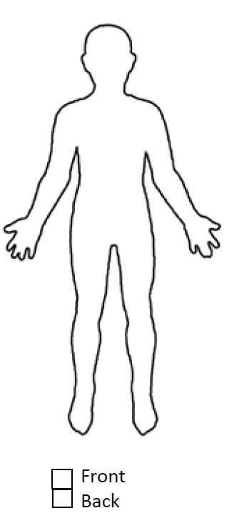
DSSL receiving form: |  |  |  |  |  |  |  | Date: |  |  |  |  | Time:
To be completed by a DSL
Agreed actions & anticipated outcomes:
Signed: |  |  |  |  |  |  |  |  |  |  |  | Date:

Appendix 2.1 First Aid parental consent form

Parent or Legal Guardian Consent

Koshiki club requires any participant who will not be at least 18 years of age on the first day of the class or event must provide consent from their parent or legal guardian to obtain first aid if necessary.
Full disclosure, informed consent to participate and liability release:

- I confirm I am the parent and/or legal guardian for the student I am registering.
- I am aware that the Koshiki will be instructing minors in a variety of martial arts techniques, training and participation.
- I grant my permission to allow the child to attend and participate in any and all activities.
- I perpetually release all Koshiki instructors, assistants from any and all liabilities that may arise from the consequences of my decision of allowing a minor to a martial arts class or event.

First Aid Consent

- I consent to basic first aid being given to the named student should they sustain an injury whilst under the supervision of Koshiki club.
- I understand that, should this occur, the Koshiki club will endeavour to contact a parent/guardian and also arrange further medical assistance if deemed necessary.
- I consent to my child receiving medical treatment that, in the opinion of a qualified medical practitioner, may be necessary.
I give permission for my child to obtain first aid if obtaining injury or illness during a Wado Class.
Child’s name: Parent/Guardian print name (s): Sign:
Contact details:
Please identify any allergies or needs:

Appendix 2.2 Accident report form

ACCIDENT REPORT FORM
Your name: | Name of organisation:
Contact information (you):
Address:
Postcode:
Telephone numbers:
Email address:
Child's name: | Child's date of birth:
Child's ethnic origin:  Please state | Does child have a disability:  Please state
Child's gender:
[ ] Male
[ ] Female
Parent's / carer's name(s):
Contact information (parents / carers):
Address:
Postcode:
Telephone numbers: | Email address:

Have parents / carers been notified of the incident?
[ ] Yes
[ ] No
If YES, please provide details of what was said / action agreed:
Are you reporting your own concerns or responding to concerns raised by someone else?
[ ] Responding to my own concerns
[ ] Responding to concerns raised by someone else.
If responding to concerns raised by someone else, please provide further information below:

Name:
Position within the sport or relationship to the child:
Telephone numbers: | Email address:

Date and times of the incident:
Please provide details of the incident or concerns:
Include other relevant information, such as description of any injuries and whether you are recording this incident as fact, opinion or heresay.

Please provide the child's account of the incident:

Please provide any witness accounts of the incident:

Please provide details of any person involved in this incident or alleged to have caused the incident / injury:
Name:
Position within the club or relationship to the child:
Date of birth (of child):
Address: | Postcode:
Telephone numbers: | Email address:

Please provide details of action taken to date
Has the incident been reported to any external agencies?
[ ] Yes
[ ] No
If YES, please provide further details:
Name of organisation / agency:
Contact person:
Telephone numbers:
Email address:
Agreed action or advice given:
Print name: | Signature: | Date:

Appendix 3 Incident report form
INCIDENT REPORT FORM

Your name: | Name of organisation:
Contact information (you):
Address:
Postcode:
Telephone numbers:
Email address:
Child's name: | Child's date of birth:
Child's ethnic origin:  Please state | Does child have a disability:  Please state
Child's gender:
[ ] Male
[ ] Female
Parent's / carer's name(s):
Contact information (parents / carers):
Address:
Postcode:
Telephone numbers: | Email address:

Have parents / carers been notified of the incident?
[ ] Yes
[ ] No
If YES, please provide details of what was said / action agreed:
Are you reporting your own concerns or responding to concerns raised by someone else?
[ ] Responding to my own concerns
[ ] Responding to concerns raised by someone else.
If responding to concerns raised by someone else, please provide further information below:

Name:
Position within the sport or relationship to the child:
Telephone numbers: | Email address:

Date and times of the incident:
Please provide details of the incident or concerns:
Include other relevant information, such as description of any injuries and whether you are recording this incident as fact, opinion or heresay.

Please provide the child's account of the incident:

Please provide any witness accounts of the incident:

Please provide details of any person involved in this incident or alleged to have caused the incident / injury:
Name:
Position within the club or relationship to the child:
Date of birth (of child):
Address: | Postcode:
Telephone numbers: | Email address:

Please provide details of action taken to date:

Has the incident been reported to any external agencies?
[ ] Yes
[ ] No
If YES, please provide further details:
Name of organisation / agency:
Contact person:
Telephone numbers:
Email address:
Agreed action or advice given:
Print name: | Signature: | Date:

Appendix 4 Photograph and social media parental consent form

PHOTOGRAPHY RELEASE FORM
Parental Consent Form for the use of photography of children and young persons Children and young persons are photographed in connection with Koshiki Club:
• Administration (License photo)
• Coaching and training aids
• Advertising, Publicity and Promotional works inclusive of club website and social media content.
- Parental photography forms an enduring part of each family’s record of their child’s progress, celebration of success and achievement, as well as being an established social practice. Parents must understand that they must do all that they can to only take photos of their own child/children and must ask the club Sensei before they do so.
We may require on a per event basis your permission for photography to be taken. ‘Photography’ includes photographic prints and transparencies, video, film and digital imaging. ‘Events’ means any function, meeting, training session or competition of any nature, whether organised or supported or sponsored by Koshiki club or their Association members by any means whatsoever, wherever children or young people are the responsibility of Aiwaikai, their staff or members or their Associations staff or members.

I do/do not (delete where applicable) give permission for photography of my child to be taken by authorised personnel for or on behalf of Koshiki club.

(Child’s name): Signed (Parent/Guardian): Date:

